Niemuth Family Memorial Scholarship Application

Qualifications
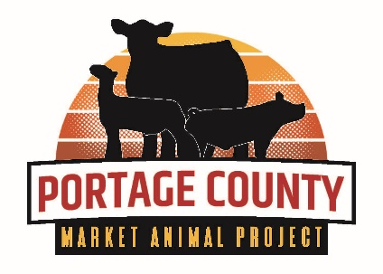
- Must be a present Market Animal Project Member.
- May apply to any field of study (post high school) at any accredited school.
- Must be used within one year from the time of scholarship award or money
must be returned to the Portage County Market Animal Committee.
- Minimum of 3 years participation in the Portage County Market Animal Project.
- Scholarship can be received only once.
- Applicant’s form must be signed by their 4-H General Leader or their FFA Advisor.

Date: / /

Name:

Home Address:

Present Address (if different):

Name and Address of High School(s) Attended:

1.

2.

3.

Name and Address of Accredited Institution of Higher Education you are or will be Attending:

Why have you chosen the field of study you are pursuing? For what reason did you choose the school you will attend?

Please summarize your interests, activities, and community involvement outside of 4-H and FFA
(you will highlight your 4-H and FFA background on the next page).

___________________________________________________________________________________________

Attach Additional Sheets if Necessary. Be Concise but Thorough.

4-H/FFA Background BAckrBackground
Years Enrolled in Portage County 4-H/FFA:
Years Enrolled in Another County 4-H/FFA Program:
Total Years in 4-H/FFA:

List All 4-H Club/FFA Chapter Offices Held

List All County or State 4-H/FFA Offices Held:

List any other 4-H/FFA Leadership Experiences:

List All 4-H Awards/FFA Awards And Degrees of Membership Received:

List All 4-H Projects/FFA Supervised Agricultural Experiences (SAE):

List All 4-H/FFA Special Activities:

Write a Paragraph on Any Other Things You May Want to Add.

Furnish at least three (3) letters of recommendation, with at least one being from a 4-H Leader or FFA Advisor.

To the best of my knowledge, all of the above information is accurate.

Markey Animal Project Member’s Signature: _____________________________________

4-H General Leader/FFA Advisor’s Signature: _____________________________________

Return Form To: Portage County Extension, 1462 Strongs Ave, Stevens Point, WI 54481
Application Deadline: August 1, 2022

