Niemuth Family Memorial Scholarship Application

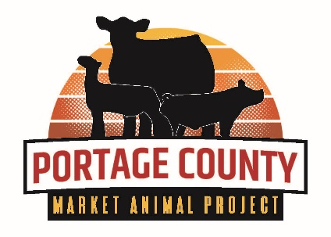
Qualifications
- Must be a present Portage County Market Animal Project Member.
- May apply to any field of study (post high school) at any accredited school.
- Must be used within one year from the time of scholarship award or money
must be returned to the Portage County Market Animal Committee.
- Minimum of 3 years participation in the Portage County Market Animal Project.
- Scholarship can be received only once.
- Applicant’s form must be signed by their 4-H General Leader, FFA Advisor or Primary Leader of their Fair Board approved
youth organization.

Date: / /

Name:

Home Address:

Present Address (if different):

Name and Address of High School(s) Attended:

1.

2.

Name and Address of Accredited Institution of Higher Education you are or will be Attending:

Why have you chosen the field of study you are pursuing? For what reason did you choose the school you will attend?

___________________________________________________________________________________________

Background in 4-H, FFA or other fair board approved youth organization:
Attach additional sheets if necessary. Be concise but thorough.

number of Years enrolled in Portage county 4-h, FFA or other fair board approved youth organization _____

number of Years enrolled in the Portage county Market animal project _____

List All Leadership Positions (officer, committee chair, etc.) Held in 4-H, FFA or other Fair board approved youth organization:

____________________________________________________________________________________________________________

List any other Leadership Experiences related to 4-H, FFA or other fair board approved youth organization:
(Examples: Swine, beef or sheep Youth Leader, Mentor for new market animal project member(s), livestock presentations and demonstrations, assisted in livestock workshops such as species meetings and practical applications, etc.)

List livestock Educational workshops and contests attended:

____________________________________________________________________________________________________________

List 4-H Awards, FFA Awards/Degrees of Membership and awards received from other fair board approved youth organizations that were based on your performance (leadership, showmanship, etc.). Do not include awards based on your livestock’s qualities (grand and reserve champions, etc.):

List All 4-H Projects, FFA Supervised Agricultural Experiences (SAE), and educational areas of your fair board approved youth organization:

____________________________________________________________________________________________________________

Please summarize your interests, activities, and community involvement outside of 4-H, FFA and other fair board approved youth organizations:

___________________________________________________________________________________________
___________________________________________________________________________________________

Furnish at least three (3) letters of recommendation, with at least one being from a 4-H Leader, FFA Advisor or Primary leader of your fair board approved youth organization.

To the best of my knowledge, all of the above information is accurate.

Markey Animal Project Member’s Signature: _____________________________________

4-H General Leader, FFA Advisor or Primary Leader of fair board approved youth organization’s Signature:

_____________________________________

Return Form To: Portage County Extension, 1462 Strongs Ave, Stevens Point, WI 54481
Application Deadline: August 4, 2023

