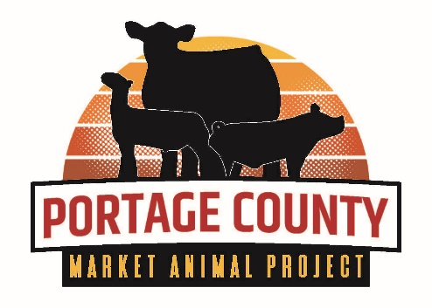
2024 Rosholt Fair Market Animal
Project Sign-Up Sheet
SUBMIT THIS FORM NO LATER THAN DECEMBER 15, 2023

This form must be completed and submitted on time if you plan to enter beef, swine, and/or sheep in the 2024 Rosholt Fair Market Animal Project. Complete and submit to:

Portage County Extension
Attn: Connie Creighton
1462 Strongs Ave
Stevens Point, WI 54481

Or sign up fully online at: https://bit.ly/2024MAPRegistration

Member Name(s): ___________________________________ Date(s) of Birth: ____________________

Age(s) as of January 1, 2024: ________________________ Grade(s): __________________________

Address: ___________________________________________________________________________

Phone: _______________________ Parent/Guardian Name(s): _______________________________

Member's and/or Parents Email Address :___________________________________________________

Name of 4-H Club or FFA Chapter: _______________________________________________________

Year in Livestock Project: _____________

I plan to have the following market animals at the 2024 show and sale – maximum of two animals per species, per exhibitor. Please circle.

Beef: 1 or 2 Swine: 1 or 2 Sheep: 1 or 2

The Market Animal Sale Committee is in need of members to share duties. Adults and members over the age of 13 are urged to join. Please come to the Market Animal Sale Committee meetings if interested.

