Portage County Market Animal Project
Graduate Award Application

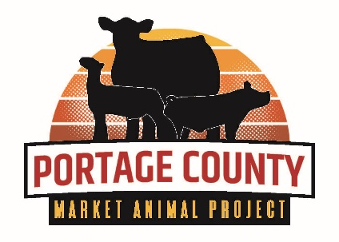
Qualifications
- Must be a current Portage County Market Animal Project Member.
- Graduating seniors or one year post graduate members are eligible.
- Minimum of 4 years participation in the Portage County Market Animal Project.
- Award can be received only once.
- Application must be signed by 4-H General Leader, FFA Advisor or Fair Board approved youth organization Leader.

Date: / /

Name:

Home Address:

Present Address (if different):

Name and Address of High School(s) Attended:

What Have You Learned from the Portage County Market Animal Project?

What Are Your Plans for the Future?

___________________________________________________________________________________________

Number of Years enrolled in Portage County 4-h, FFA or other fair board approved youth organization _____

Number of Years enrolled in the Portage County Market Animal Project _____

Background in 4-H, FFA or other fair board approved youth organization:
Attach additional sheets if necessary. Be concise but thorough. answer all questions.

1. List All Leadership Positions Held in 4-H, FFA or other Fair board approved youth organization (Examples: Officer, Committee Chair, Swine, Beef or Sheep Youth Leader, etc.):

2. List all other Leadership Experiences related to 4-H, FFA or other fair board approved youth organization:
(Examples: Mentor for new market animal project member(s), livestock presentations and demonstrations, assisted in livestock workshops such as species meetings and practical applications Meetings, etc.)

____________________________________________________________________________________________________________

3. List All Virtual and In-Person livestock Educational Workshops and Contests attended:

____________________________________________________________________________________________________________

____________________________________________________________________________________________________________

4. List all 4-H Awards, FFA Awards/Degrees of Membership and awards received from other fair board approved youth organizations that were based on your performance (leadership, showmanship, etc.). Do not include awards based on your livestock’s qualities (grand and reserve champions, etc.):

5. List All 4-H Project areas, FFA Supervised Agricultural Experiences (SAE), and educational areas of your fair board approved youth organization:

____________________________________________________________________________________________________________

6. Please summarize your interests, activities, and community involvement outside of 4-H, FFA and other fair board approved youth organizations:

7. Furnish at least one (1) letter of recommendation.

To the best of my knowledge, all of the above information is accurate.

Market Animal Project Member’s Signature: _____________________________________

4-H General Leader, FFA Advisor or Primary Leader of fair board approved youth organization’s Signature:

_____________________________________

Return Form To: Portage County Extension, 1462 Strongs Ave, Stevens Point, WI 54481
Application Deadline: August 1, 2024

