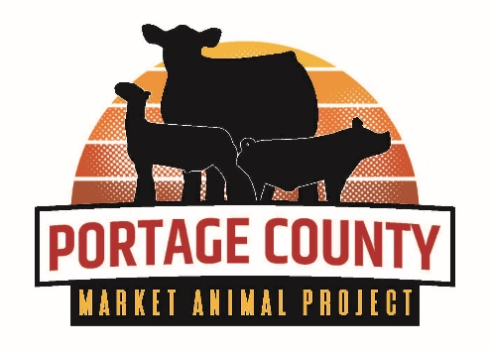
2026 Rosholt Fair Market Animal
Project Sign-Up Sheet
SUBMIT THIS FORM NO LATER THAN NOVEMBER 15, 2025

This form must be completed and submitted on time if you plan to enter beef, swine, and/or sheep in the 2026 Rosholt Fair Market Animal Project. Complete and email to: pmap.secretary@gmail.com

Or sign up fully online at: https://bit.ly/PoCoMarketAnimal

Member Name(s): ___________________________________ Date(s) of Birth: ____________________

Age(s) as of January 1, 2026: ________________________ Grade(s): __________________________

Address: ___________________________________________________________________________

Phone: _______________________ Parent/Guardian Name(s): _______________________________

Member's and/or Parents Email Address :___________________________________________________

Name of 4-H Club or FFA Chapter: _______________________________________________________

Year in Livestock Project: _____________

I plan to have the following market animals at the 2026 show and sale – maximum of two animals per species, per exhibitor. Please circle.

Beef: 1 or 2 Swine: 1 or 2 Sheep: 1 or 2

The Market Animal Sale Committee is in need of members to share duties. Adults and members over the age of 13 are urged to join. Please come to the Market Animal Sale Committee meetings if interested.

