2026 Wayne Schroeder Portage County 4-H Scholarship & 2026 Pinkerton-Burns-Noble Portage County 4-H Scholarship Application
Qualifications
- Must be a present or former Portage County 4-H Member or Leader.
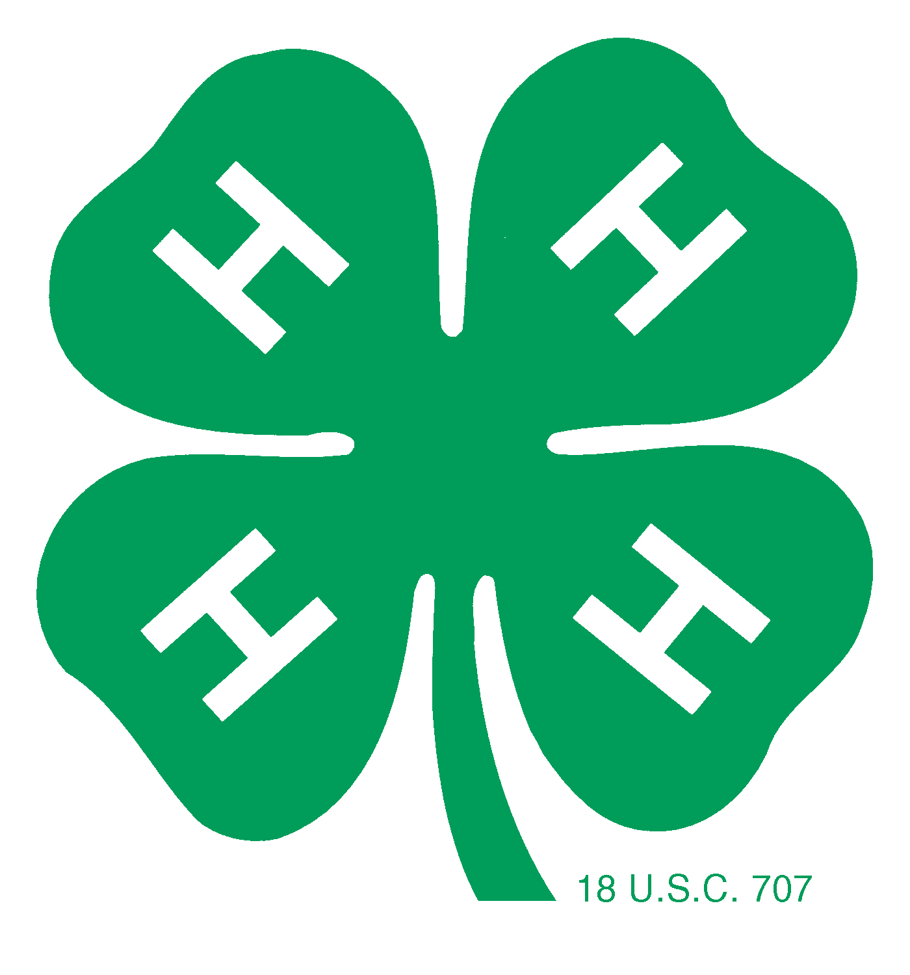
- May apply to any field of study (post high school) at any accredited school.
- Must be used within one year from the time of scholarship award or money
must be returned to the 4-H Leaders Association
- Minimum of 2 years as a project or youth leader at the club level. Provide detailed list
of experiences where projects are listed on this application.
- Minimum of 3 years participation in 4-H.
- Scholarship can be received only once.
- A leader’s form must be co-signed by a general leader or county educator.
- A member’s form must be signed by their general leader.
Date:
Name:
Home Address:
Present Address If Different):
Name and Address of High School(s) Attended:

Name and Address of accredited institution of higher education you are or will be attending:

Why have you chosen the field of study you are pursuing? What is the reason you chose the school you will attend?

How has your experience in 4-H prepared you for your career path?

Number of Years in 4-H _____ Number of years in Youth Leadership Project _____

Background in 4-H
Attach additional sheets if necessary. Be concise but thorough. Answer all questions.

1. List all leadership positions held in 4-H (Examples: Club or Teen Leader Officer, Committee Chair, Youth Leader in Club or County Project(s), etc.)

2. List all other leadership experiences related to 4-H (Examples: Mentor For New Club Member(s), Educational Presentations And Demonstrations, Assisted In County Workshops, 4-H Camp Counselor, 4-H Ambassador, etc.):

3. List all club and county activities you participated in (Examples: Community Service, Member Recruitment, Fundraising, Recreation, etc.):

4. List all virtual and in-person 4-H educational workshops and 4-H state and national events that you attended:

5. List all 4-H contests that you participated in (Examples: Speaking, Demonstration, Livestock Judging, Style Review, Fairs, Virtual Contests, etc.):

6. List all 4-H awards received based on your performance (Examples: Leadership, Showmanship, Talent, Creativity, etc.):

7. List your major 4-H project areas:

Summary of Non-4-H Involvement

8. Please summarize your interests, activities, and community involvement outside of 4-H:

9. Furnish one letter of recommendation.

To the best of my knowledge, all of the information in this application is accurate.

4-H Member’s Signature:

4-H General Leader’s Signature:

Return Form To: Portage County Extension, 1462 Strongs Ave, Stevens Point, WI 54481
Application Deadline: March 15, 2026

